American International University-Bangladesh



COMPUTER GRAPHICS Course Code: CSC4118

Spring Semester 2023-24

**Project Report**

**Harmonious Coexistence: Bridging Urban and Rural Landscapes**

**Course Instructor**

**Aneem Al Ahsan Rupai**

**Lecturer**

**Department of Computer Science, FST**

**Name: MAHADI HASAN NAYEEM**

**Id: 22-46137-1**

**Section: A**

**Table of Contents:**

|  |  |
| --- | --- |
| Topic | Page Number |
| Introduction | 3 |
| Project Graph | 3 |
| List of Objects | 5 |
| List of Functions (Represent Object) | 6 |
| List of Animation Function | 7-8 |
| Output Screenshot | 8 |
| Conclusion | 9 |

**Introduction:**

In this computer graphics project, we present a vibrant and detailed visualization of the Joydebpur Railway Station area. The scene captures the essence of the bustling station environment, featuring key elements such as roads, buildings, lamps, benches, station shade, and trees. Animated vehicles, including a train, a bus and a truck, enhance the dynamic interaction, illustrating the movement and connectivity around the station. The presence of T-stalls and the station's signage adds authenticity to the depiction. Clouds in the sky contribute to the overall ambiance and realism of the scene. This project, "Joydebpur Railway Station Area," showcases the harmonious integration of various infrastructural components and the vibrant activities of a thriving urban space, inviting viewers to appreciate the intricate and lively interplay of this essential community hub.

**Project Graph:**

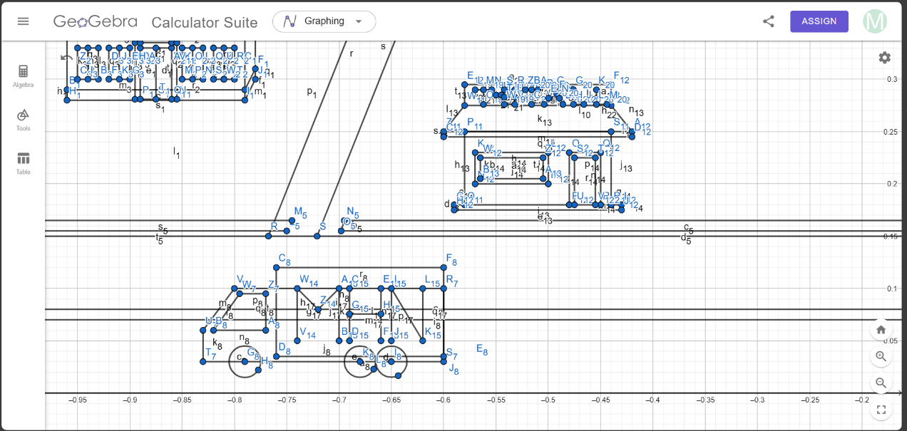

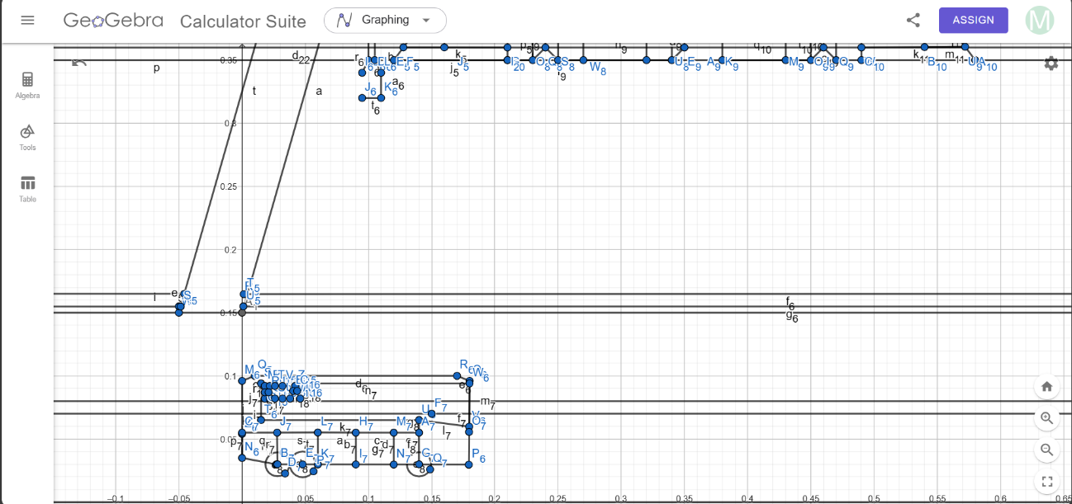

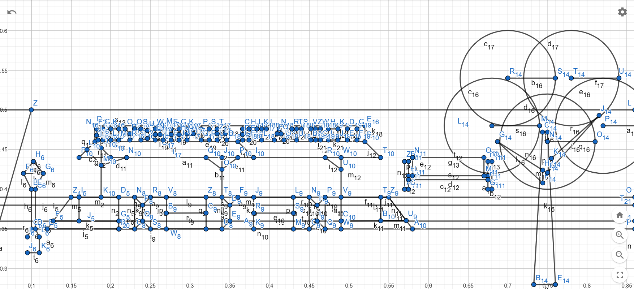

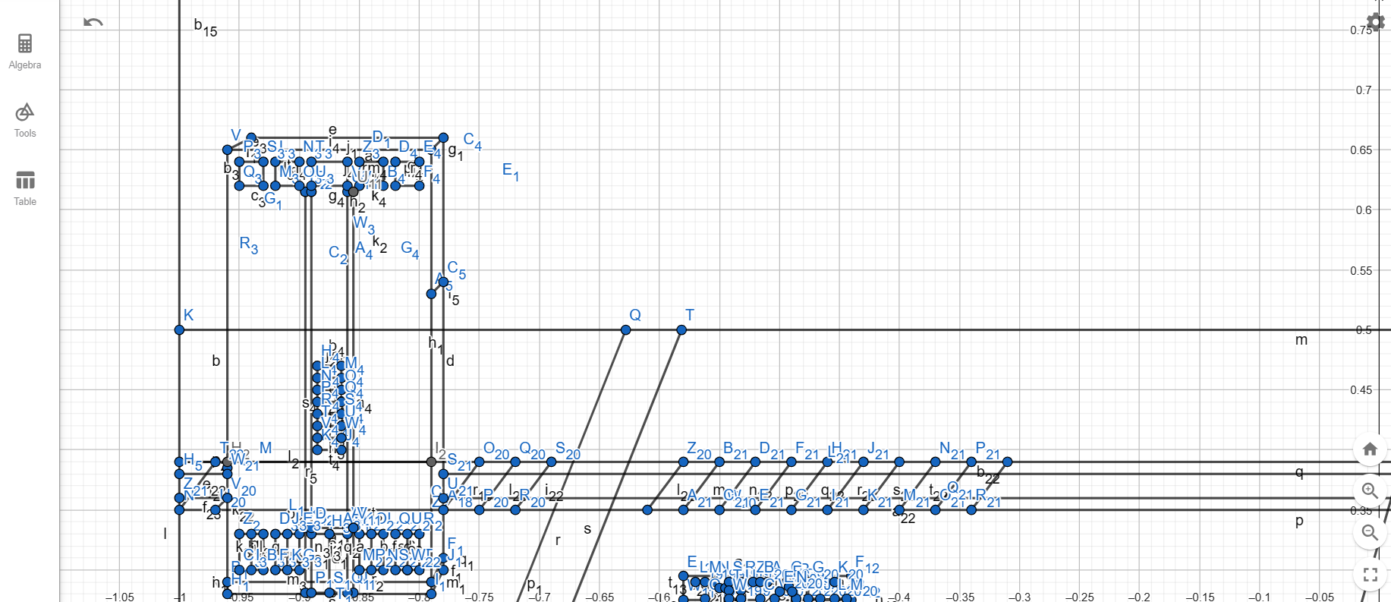

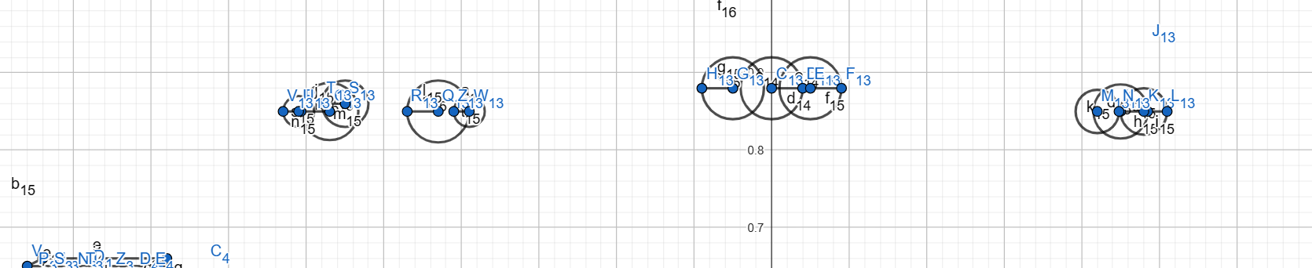

**List of Objects:**

|  |  |  |
| --- | --- | --- |
| SL# | OBJECT ID | OBJECT NAME |
|  | Building-1, 3,4,5 | buildingn |
| 2. | Tree -5 | treen,moretreen |
|  | Truck-1 | truckn |
|  | Rail Station | railstationn |
|  | Road -4 | roadn |
|  | Train | trainn |
|  | Cloud-1,2,3 | Cloudn |
|  | Bus | busn |
|  | T stall shop-2 | shopn |
|  | Bench-2 | benchn |
|  | Lamp-10 | lampn |

**List of Functions:**

|  |  |  |
| --- | --- | --- |
| SL# | OBJECT NAME | FUNCTION NAME |
|  | Cloud | cloud1n() |
|  | Cloud | cloud2n() |
|  | Cloud | cloud3n() |
|  | Road | mainroadn() |
|  | Roadblock | blockn |
|  | Building | building1n() |
|  | Building | building3n() |
|  | Building | morebuilding1n |
|  | Building | morebuilding3n() |
|  | Building | building4n() |
|  | Building | building5n() |
|  | Lampline | lamplinen() |
|  | Lamp1 | lamp1n() |
| 14. | Lamp | morelamp1n() |
| 15. | tree | treen() |
| 16. | tree | moretreen() |
| 17. | train | trainn() |
| 18. | truck | truckn() |
| 19. | Bus | busn() |
| 20. | Rail station | railstationn() |
| 21. | Bench | benchn() |
| 22. | Bench | morebenchn() |

**List of Animation Functions:**

|  |  |  |  |
| --- | --- | --- | --- |
| SL# | Animation Function ID | Animation Function | Object/ Scene |
| 1 | Animation Function 01 | busn() | bus |
| 2 | Animation Function 02 | truckn() | truck |
| 3 | Animation Function 03 | trainn() | train |
| 4 | Animation Function 04 | cloud1n() | Cloud |
| 5 | Animation Function 05 | Cloud2n() | Cloud |
| 6 | Animation Function 06 | Cloud3n() | Cloud |

**Output Screenshot:**

**Conclusion:**

In conclusion, this project successfully integrates a railway station and its surrounding area using advanced coding techniques in OpenGL and C++. Far beyond a simple static display, it offers a dynamic blend of various scenarios and controllable elements that provide an immersive and enjoyable experience. This project effectively transforms imaginative ideas into a tangible digital reality, allowing users to actively shape movements and activities within the scenario. By incorporating an educational and explorative dimension into coding, the project makes the subject more engaging, interactive, and accessible to a wider audience. Furthermore, by simulating the integration of a railway station area, it vividly demonstrates the practical application of coding in solving real-world problems. This project turns the digital environment into an interactive and fun playground, highlighting the potential of coding to create meaningful and impactful solutions in a digital context.